
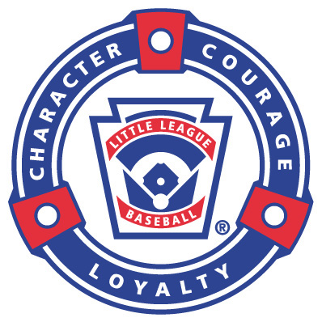
FONTANA COMMUNITY
LITTLE LEAGUE
PLAYER CODE OF CONDUCT

Fontana Community Little League expects the following standards of conduct and behavior of all players:

1. Play for the fun of the game.
2. Show good sportsmanship at all times – win or lose.
3. Respect your coaches, teammates, opponents, parents and umpires.
4. Be a team player and get along with your teammates.
5. Learn the rules of the game and play by them.
6. Try your best at all times.
7. Work hard and try to improve your skills.
8. Never argue with or show disrespect towards the umpire or coaches.
9. Be positive with your teammates. Don't criticize.
10. Do not harass or act disrespectfully towards the opposing team.
11. Regularly attend practices and games.
12. Be on time.
13. Do not throw bats or helmets. These actions can lead to an immediate ejection from a game.
14. Do not intentionally hurt another player. This will lead to an immediate ejection from the game, suspension from future games, and/or dismissal from the team.
15. Never swear or use profane language.
16. Clean up the dugout after every game. Ask the coach what else you can do to help.

Player: _______________________________________________

Date: _______________________________________________

Fontana Community Little League
15218 Summit Ave. #300-607
Fontana, CA 92336

